LAB 1.1 GABRIEL EKE T00665716

Open new file and select processor type

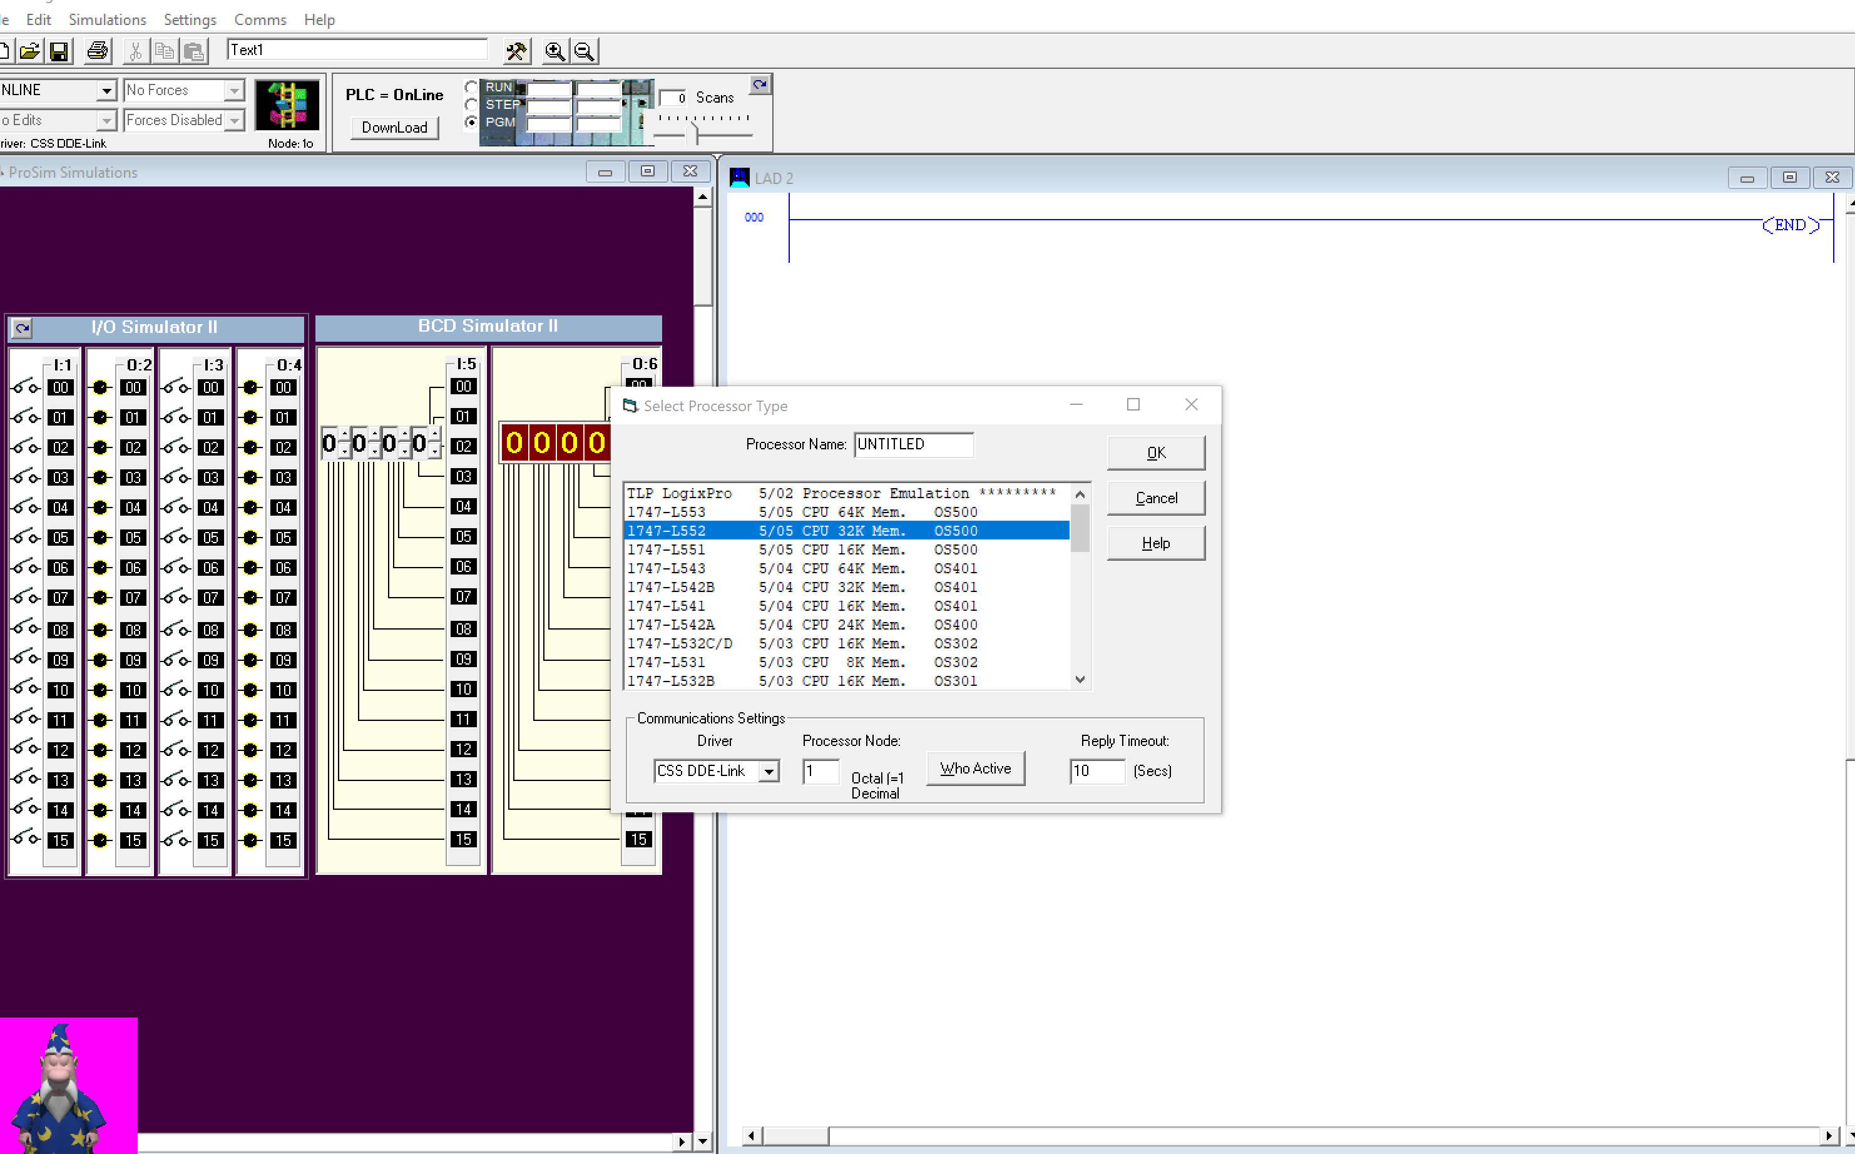

Create ladder on 000 ladder

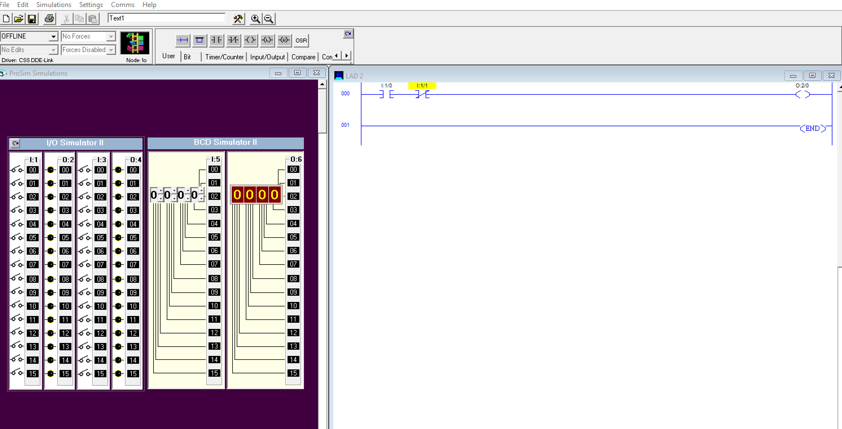

LAB 1.2: Edit inputs and tags

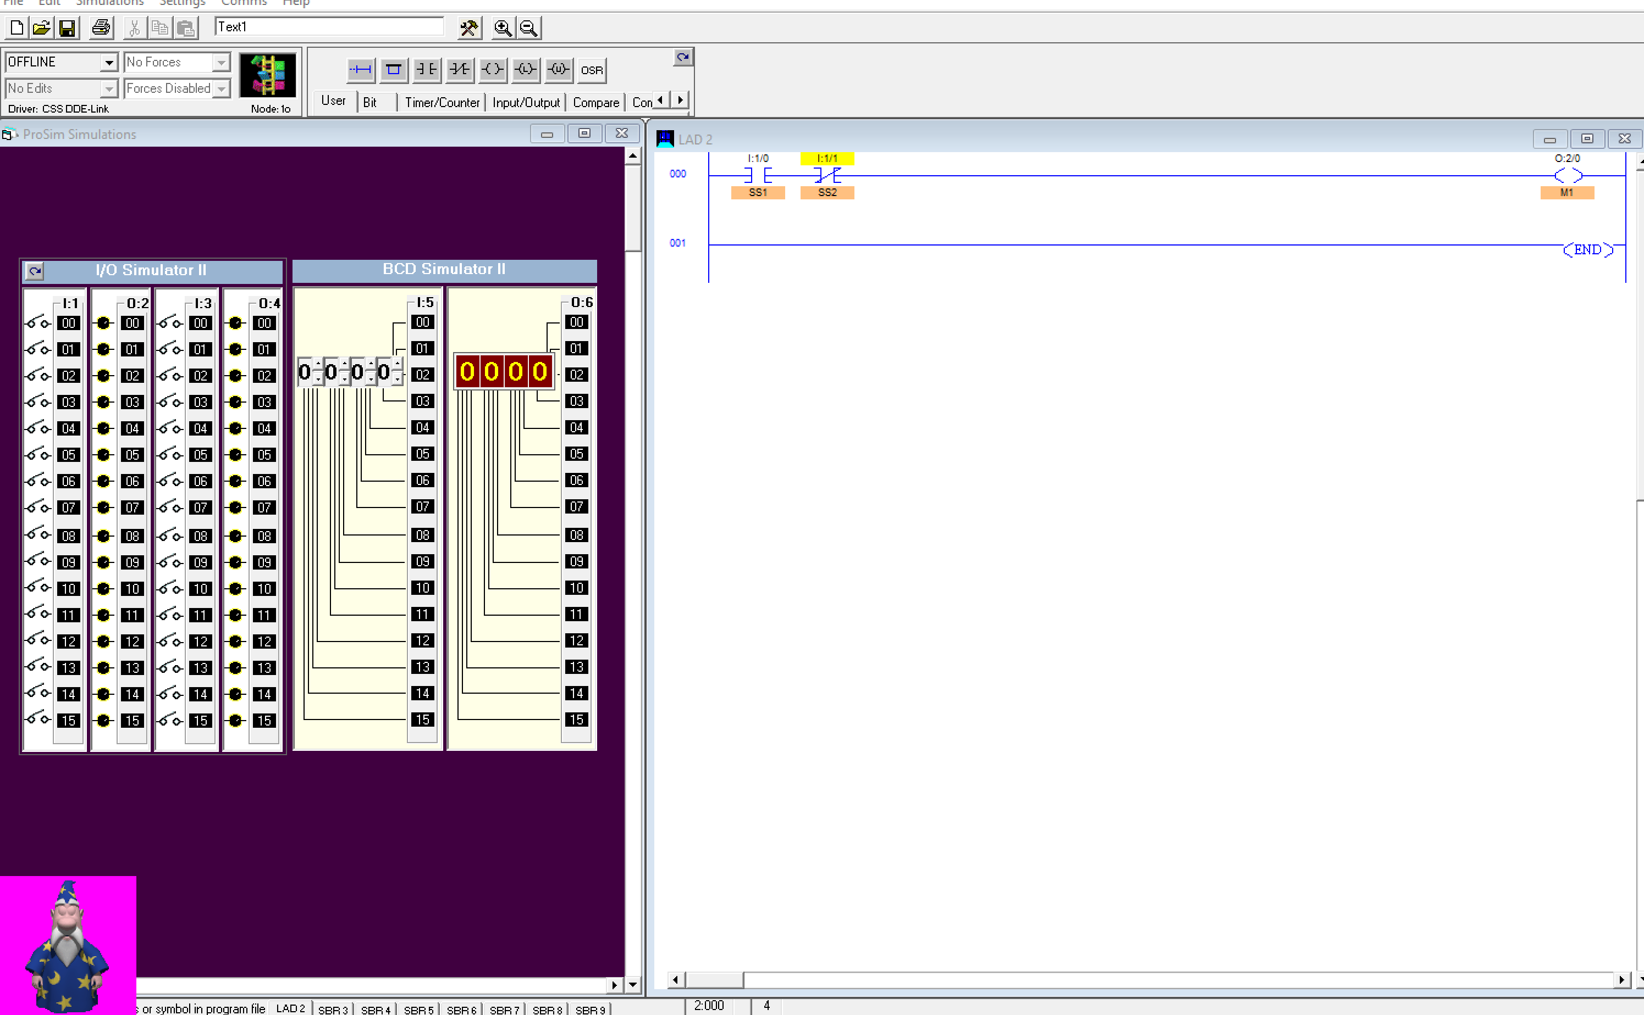

Download and click button

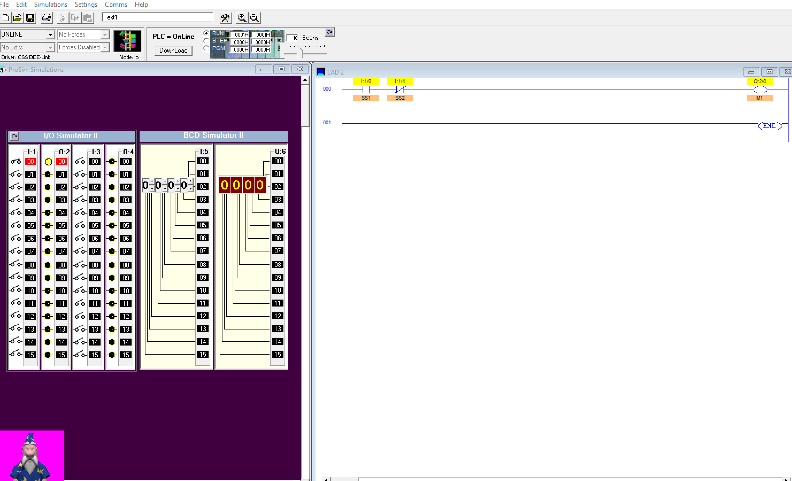

LAB 1.3

Step 1: open new file and selete processor

Step 2: create ladders

Step 3: edit input and output tags

Step 4: download and run

